Placement Assignment: Live Skills (PALS)
Preparation and Recording Clinical Work
The three PALS assignments each comprise a 30-minute clinical recording from your placement and a 4500-word written report. The PALS assesses both the ‘live skills’ of the trainee and their ability to reflect on and critically appraise their work. All trainees are required to submit three PALS assignments over the course of their training.
Trainees in the 2021 cohort (and subsequent cohorts) will submit PALS #1 and #2 from work completed on their direct skills placement, and PALS #3 from their indirect skills placement. In exceptional circumstances PALS recordings can also be submitted from the Influencing and Leadership placement.
Trainees from earlier cohorts will submit PALS #1 based on work from their first placement and PALS #2 and #3 from two different subsequent core practice placements.

Latest versions of all documents associated with this assignment can be found on the PALS programme handbook webpage. This document outlines what you need to be aware of in terms of your responsibilities associated with the clinical recording, including gaining informed consent from your client and ensuring the safe storage and transportation of the recording.
Please familiarise yourself with the content in this document early on in your placement, and make sure you are aware of your responsibilities concerning the clinical recording process. Failure to act accordingly at all times with this guidance may lead to professional behaviour concerns being raised.
Further details on how to approach the written component of the PALS are available in a separate document (available on the PALS programme handbook webpage). We would also recommend that you look carefully at the Trainee Feedback Form (available on the PALS programme handbook webpage) for details of the kinds of evidence that markers are looking for within each of these domains. We appreciate that there is a lot of information included in these documents – please read them carefully and contact the Assignment Coordinators if you have any questions.

Domains Actively Assessed in the PALS
Indicators of the kinds of evidence that markers might look for under active and passive domains is available on the Trainee Feedback Form. These indicators are there to provide examples of what evidence at each level might look like – they are not an exhaustive list. Due to the wide variety of placement work that might be submitted for PALS, it would be impossible to provide a list of objective markers – different PALS assignments might look very different.

Recording Clinical Work
We encourage trainees and supervisors to see the recording of clinical sessions as a normal part of training and development on placement. You should discuss recording with your placement supervisor at the outset of a placement and consider any potential barriers/issues specific to the service.
Recording is required for this assignment, and you will need to choose a recording to submit and write up for the PALS. However, there are many other benefits to recording your clinical work and taking it to clinical supervision. You can discuss your recordings in supervision with your placement supervisor as part of the supervisor placement requirements to observe your work, which will facilitate discussion of your skills and competencies in supervision.
PALS can feature recordings of direct 1-1 work or indirect work completed on placement (e.g., facilitating a group, providing training or team consultation). The PALS should help you to reflect on the routine clinical work you are conducting on placements during your training. We recommend that you get into the habit of recording as much of your clinical work as possible. This may involve asking as many of your clients as possible for consent to record sessions and thinking about how other kinds of work (e.g. indirect work such as consultation with colleagues or training sessions) could be recorded. Recording as much clinical work as possible gives you lots to talk about in supervision and provides more options for you when it comes to choosing a suitable recording to select for the PALS.
The clinical work you present does not need to be perfect or flawless – the PALS is assessing your ability to think critically about, reflect on and learn from conducting evidence-based psychological work on placement – as outlined by the domains described above.

Obtaining Consent to Record
Direct Work
Trainees are required to obtain informed consent to proceed with recording and using someone’s personal/clinical information. We expect trainees to routinely record their clinical work on placement whenever they can obtain consent to do so, and this is something we advise you discuss and practice with your supervisor early on in training. Gaining informed consent can be a complex process and we cannot cover every possible situation in this guidance; please read this section carefully and discuss any concerns with your supervisor and/or the Assignment Coordinators.
You will need to discuss with your supervisor how you plan to approach specific clients or colleagues to gain informed consent for recording, ensuring you are adhering to any local procedures on this. You may also need to discuss with your supervisors any adaptations you plan to make so that the process is accessible for the client, considering any individual needs they may have. Please discuss this with your supervisor and record the process undertaken and outcome where necessary (e.g., in the client notes).
Before your work can be submitted for marking, a Supervisor Declaration Form (available on the PALS programme handbook webpage) must be completed and sent to the programme by your placement supervisor – this provides confirmation that appropriate informed consent has been sought. You will need to supply your supervisor with the PALS title based on the recording/piece of clinical work you have chosen for submission in order for them to complete this form. The Supervisor Declaration form needs to be returned to the programme from the supervisor’s email account. Forms sent by trainees will not be accepted.

A sample Client Information & Consent Form is available on the PALS programme handbook webpage. However, we want to be clear that gaining informed consent is not just about filling in a form – it is a process of ensuring that information has been provided and understood. It is important that you are thinking about the context of the work, the individuals involved and any needs they may have.
If you use a different form or adapt the sample form, you should append blank versions to the written component of your submission to illustrate the process you undertook to gain consent to your submission. Please be aware that, if you are making changes to the consent form, your version must include the information about how someone can contact the university to access any information held about them (this is both a university and legal requirement).
If a person is unable to complete a signed form due to the work being completed remotely then it may be more appropriate to ask for an electronic version to be returned. If the person has difficulties with reading/writing, you should ensure they have been provided with the necessary information (as detailed on the consent form above) in an accessible way and then document this process along with whether or not they have given verbal consent in their clinical record.
Please keep any signed consent forms with the client’s notes (scanned if electronic note-keeping is in use). Completed consent forms are NOT submitted to the university as part of the assignment, as this could breach the person’s anonymity if their name is recorded.

Indirect Work
If you intend to submit a recording of indirect work you will need to discuss with your supervisor the most appropriate route of gaining appropriate consent from anyone involved – as above, this should include the key information outlined on the example consent form discussed above. You may need to change some of the wording of it to suit your purposes.
For example, if you are doing something which focuses on a specific client or service user (e.g. a consultation or supervision session with another professional) you will need to gain consent from both the professionals involved and the service user – if someone’s personal information is being discussed on a recording, it is important that they are able to provide informed consent for this. If you have no direct contact or relationship with the service user, it may be most appropriate for another professional involved to approach the client on your behalf. Below are some suggestions about wording/considerations to support the professional to do this:
- That as part of their work and to ensure the quality of their work they have discussed the clients' case with a trainee psychologist to gain a psychological perspective.
- The trainee psychologist wants to use the content of the discussions between me (the professional) and the psychologist as part of a piece of work they have to submit as part of their training.
- The focus will be on how the trainee is developing their skills in terms of how they have been helping/supporting me, but they will also need to give some background details about the discussions I have had with them about the work we have done together.
- The psychologist has asked me to ask you if this is OK. They will make sure that any details they give are anonymous.
- They have given me an information sheet to give/go through with you so you are able to make an informed decision about whether this is OK or not.
- You can choose to say no - which will not affect your treatment in any way.

If you are running something like a training session which is not about a specific individual, you will still need to gain consent from everyone who attends and might appear on the recording.
We cannot provide guidance for every possible scenario. However, we hope these principles of informed consent are clear enough to guide your discussions with your supervisor. This may inform how you set up sessions – for example, if providing a training session to a team on a general topic, you should consider explaining to participants at the start that they should not mention individual service users as you do not have their consent to be featured on the recording.
A Supervisor Declaration Form is still required for indirect work, as this provides confirmation that appropriate consent has been sought for the work.

Capacity to Consent
If an individual is deemed not to have the capacity to consent to being recorded/having their information used as part of a PALS, please use the principles of a best interests decision process i.e. consider who is best placed to advocate for/weigh up/consider whether to allow the persons information to be used as part of an academic assignment (e.g. family member, key worker, social worker, advocate etc.). You may need to speak to multiple people to get different perspectives. Whilst there may be no obvious direct benefit to the person from being recorded, a trainee is likely to develop their skills and understanding as part of the process which could be of benefit to the client and their situation if work on the academic assignment is carried out whilst still on placement. As there is contribution to the trainee’s learning there is also a contribution to the trainee’s future practice and future clients. A person’s values and previous behaviour may guide these discussions. If working with a young person, you may wish to consider principles of ‘Gillick competence’ when thinking about whether the client can consent to being recorded and having their information used as part of a PALS. Again, we cannot cover every possible scenario – you need to think carefully about these issues with your supervisor.
You will need to ensure details of these processes are clearly documented as part of the client’s clinical record. You may also wish to discuss this in the written component of your PALS, to evidence your competencies.

Anonymity and Identifying Information
Identifiable information in PALS recordings
There are situations where identifiable information is captured within a recording (e.g. a person in the video identifies a name, location or service; or a client's name is visible in a recording of a remote session). We cannot edit individual videos before submission, so it is important that this is discussed with the person being recorded (or the client being discussed) as part of your process of gaining informed consent that they are happy to proceed knowing this information is part of the recording.
You should discuss the potential for this before starting the recording, and problem solve where you can - e.g. "I can see your name on the bottom of the Teams call, which means others who watch the video will be able to see that too - are you happy with that, or do you want to log back in with a different name/email address?".
In addition to speaking to the person/people involved before the recording is made, we recommend that you also ask at the end of the session if they are still happy for the recording to be used for the PALS. Check out specific examples that have arisen through the recording - e.g. "You mentioned your wife's name in the session there - are you still happy for me to use this recording as we discussed earlier?".
We want to ensure that people feel comfortable with the recording being used and that they understand who might be able to see it (e.g. markers, supervisors). We appreciate this may result in a small number of people withdrawing consent after a session (if, for example, they speak about something in more depth than they planned to). However, it is critical that consent is an informed and collaborative process. Please discuss any issues around consent with your placement supervisor.
This is a change from previous guidance; you no longer need to contact us about redacting information (such as a client's name) from a recording - they should be giving informed consent for the recording to be used 'as is', without editing. Please follow this process going forwards for any new recordings you make from here on.
We have made this change because we want ALL information in recordings to be treated as highly sensitive and potentially identifiable. All details contained within a recording (including the person's voice/appearance, things they say and personal details) are extremely sensitive information. This underpins the need for absolute care and caution in how you manage/safeguard these recordings (more on this below).
Please be aware that we are unable to edit/redact recordings. If conducting an indirect session and a client’s details are mentioned, you will not be able to submit this recording without the client’s consent. As discussed above, please think about issues around consent and the potential for identifiable information ahead of time and do whatever you can to manage and control for any issues.
Additionally, the written component of the PALS is archived by the programme alongside other academic work after the marking processes have been completed. As such, it is important that the written component (and the transcript which forms part of it) does not contain any potential identifying information - even if identifiers are present on the recording.

Recording Clinical Work
Recording face-to-face work
To record clinical work as part of your PALS, you will be provided with an LSCFT laptop, which is equipped with a built-in camera and microphone. You can plug an external microphone into your LSCFT laptop if you wish to improve sound quality, though in our experience the built-in laptop microphones are good enough if you position the laptop nearby and you are recording in a quiet space. Do not use any other cameras/laptops/tablets to record clinical work. You should use the pre-installed software ‘Camera’ to record audio and video – recordings will be saved onto the laptop.
If possible, set up the camera so that everyone is included in the shot – for example, you and the client. If there are multiple people in the room or the layout of the room means you cannot get everyone in the shot (or indeed if someone does not want to be in the shot), at least make sure you can be seen clearly. It will be much easier for your markers to provide qualitative feedback in the marking process if they can see your face and body language. Don’t put the laptop too far away, otherwise the sound quality will be poor.
We strongly recommend doing some practice runs with a friend/colleague to get used to the camera – make sure you know how close it needs to be to ensure that everyone can be heard clearly. Make sure that you can start and stop recordings smoothly and confidently, so that this does not interfere with your clinical work.
See ‘Troubleshooting’ below for common issues.
Recording Quality and File Sizes
You must avoid recording in ‘high definition’ as this results in large file sizes which create issues with sharing the files with markers, in addition to taking up the limited storage capacity you have on your OneDrive and university H:/ accounts.
You may need to change the video quality of the Camera app in settings. Check this before you start recording. You may need to change this setting every time you record, as it often returns to the default after a reboot.
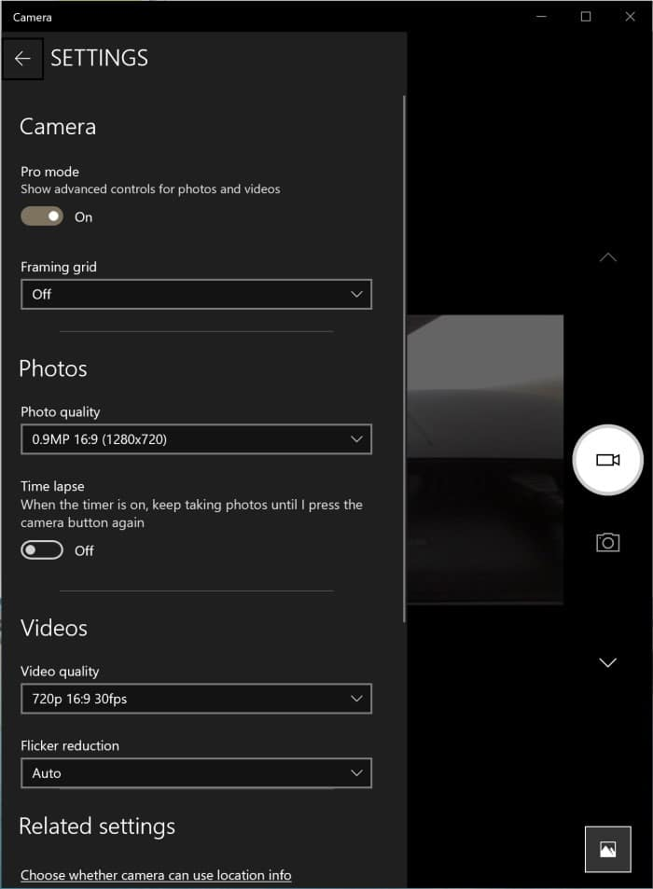

Please get into the habit of checking these settings every time you need to record.
If you have accidentally recorded into a high-quality format and have been left with a large file(s), you should convert it into a lower quality/smaller file before you submit the recording for marking. As a ballpark figure, we would expect a 60-minute recording to be approximately 1gb. If your file is much over 1.5-2gb, we would recommend converting it to a smaller size.
This conversion process is quite time consuming and unreliable – You don’t want to be doing this for every recording you make! We strongly encourage you to avoid the need for this by recording into the lowest quality possible (as described above) to keep file sizes to a minimum.
If you do need to reduce the file size, do the following;
- Download VLC (if this is not on your LSCFT laptop, you will need to speak to IT Helpdesk OR access the video on a University machine from One Drive).
- On VLC, choose File/Media > Convert/Stream
- Open Media – choose the file you wish to convert
- On video profile, choose H.264 + MP3 (MP4).
- On Mac, click Customise
- Encapsulation – MP4/MOV
- Video codec – H.264
- Audio codec – mp3
This should produce a new, smaller file (but will not delete the original file) – please CHECK that the new file you create works okay by opening it in VLC before you delete the original. If VLC cannot open/play it, or if there is no audio, something has gone wrong with the conversion process and you may need to do it again. Once you are sure it works in VLC, upload the file to OneDrive and check that the video/audio both work when the file is streamed. If there is a problem with this, you may need to repeat the conversion process. PLEASE ensure that you check these files work on VLC and OneDrive before you delete the original. If there is a problem with the conversion and you delete the original, there will be no way to recover it!
It is your responsibility to ensure that the video file you submit for your PALS works on OneDrive – leave yourself plenty of time to convert it and check that it is working okay. We cannot be responsible for any lost recordings and any technical problems will not be considered as reasons for delayed submission (please see the deadlines policy on the programme handbook webpage).
Again, we want to emphasise that this should be a last resort. We cannot provide any further technical support for converting recordings beyond the steps described above. Many trainees have experienced difficulties with this, so we strongly encourage trainees to record in lower quality to create small file sizes and avoid the need for any conversion.

Recording remote work
If you are recording an online/remote session using Microsoft Teams, you should ask your placement trust’s information governance department whether you need to use your Lancaster University account, LSCFT account or placement trust Teams account to record the session. Whatever account you use, you should
only use your LSCFT laptop for sessions that are to be recorded. Any recordings made in Microsoft Teams should be downloaded and then saved to your University H:/ using your LSCFT laptop, as per the processes described later in this document (n.b. Teams recordings may be quite large as you cannot change the quality settings – you are not expected to convert/reduce these recordings).
If your placement trust uses another software platform (e.g. Zoom, Attend Anywhere) and you can login to this on your LSCFT laptop, you can record the screen/audio using VLC by selecting Open Capture Device under the File menu, and selecting screen and audio settings. This will allow you to save a recording directly onto your secure LSCFT laptop. Please note you may need to contact LSCFT IT Team and ask them to install VLC for this purpose.
If you are required to use your placement’s account/software (rather than your university or LSCFT account) but are unable to login to these on your LSCFT laptop, you should use your placement’s laptop/computer to run the session and then point your LSCFT laptop’s camera at the screen of the device you are using and record audio/video using the Camera app. Where possible, position the camera so that both you and the client (on screen) are visible. If there are any issues with having the loudspeaker on (e.g. if you are struggling to find a private space) then speak to your supervisor/tutor about options for alternative venues.
Similarly, if you are using a telephone, you can put the phone on loudspeaker and record using the Camera app on your LSCFT laptop. You could also use a telephone pickup microphone to connect the phone to your LSCFT laptop (these are available online for a few pounds). This will enable you to record using the Camera app, with the input set to the pickup microphone.
For those of you who are on an LSCFT placement, the IG team have given permission for you to use your LSCFT Microsoft Teams account to record sessions. Your LSCFT laptop should enable you to login to your LSCFT Microsoft Teams account (if any issues with this, discuss with the LSCFT IT Helpdesk). Many services use a generic/admin account to send invites; if you are setting up your own meetings, you should avoid sharing your LSCFT email address with clients. You can do this by entering email addresses into the ‘Resources’ field when setting up the invitation;
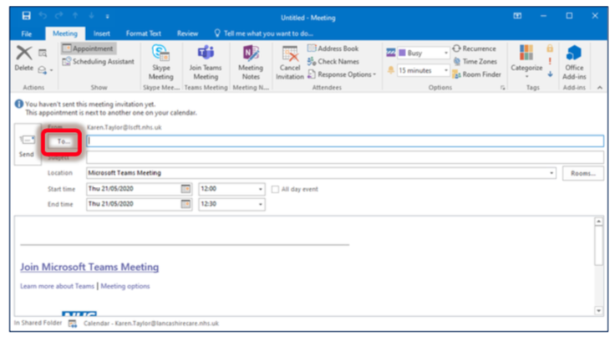
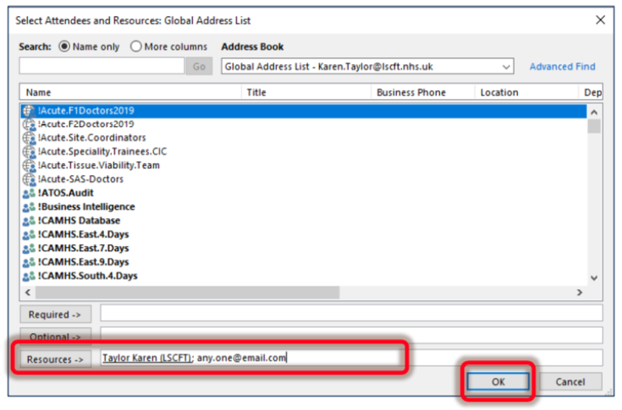
It is your responsibility to discuss local processes with your placement supervisor as soon as you can and liaise with relevant information governance departments if needed. Please raise any issues with the Assignment Coordinators.
Troubleshooting - Recording Problems
Save Location. The LSCFT laptop will save to a network drive by default. If the wifi/internet connection is unreliable or drops, the recording may not save correctly and may be corrupted.
If your service has poor wifi connection or you are recording somewhere without internet, you can change the recording save location. This should prevent any difficulties when saving recordings. If you are getting error messages or finding problems with recordings saving, we recommend that you try this.
To change where recordings are saved;
Go to your desktop, Right click > New > Create folder. Name this folder “Recording”.
Once you’ve created this, we’ll need to change the save location. Go to file explorer and open the Pictures folder. Open the Camera Roll folder, right click and choose Properties.
Select the Location tab, then choose Move and select Desktop then the “Recording” folder.
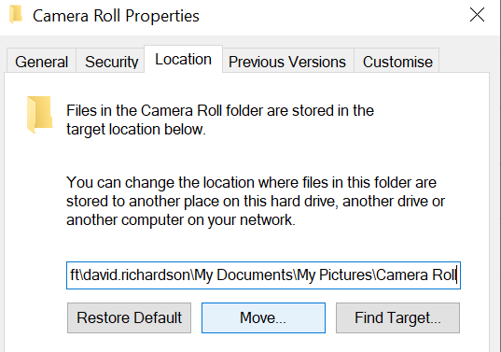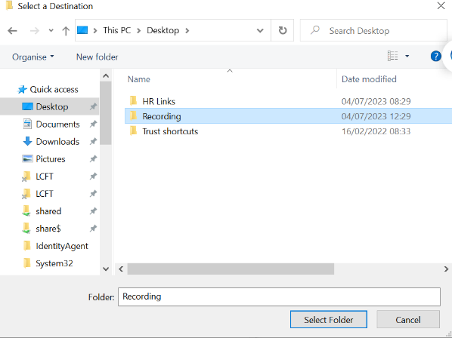
You’ll get a prompt asking if you want to move your current recordings. Press no, as these will be safe on the network. Once it’s applied, you will need to restart your device. Check this before you record as it may revert to defaults.
IMPORTANT – After you have saved a recording to the Desktop folder as per these steps, you will need to transfer it to your documents folder on the LSCFT Network drive as soon as you have access to internet again. Then, you will need to follow the steps described below to transfer the recording to OneDrive and/or your University H:/

Power Settings. Some trainees have also found the power/security settings mean the laptop goes into sleep mode while recording. Trainees have been advised by IT to check their power/sleep settings are not set to turn the machine off after a short period. If you are having problems with this, remove the Smart Card and disconnect from wifi (after following the above steps to change the save location). If you have further issues, please discuss with the PALS assignment coordinators.
Safe and Secure Management of Recorded Material
You are responsible for your LSCFT laptop – please look after it.
You are responsible for the secure management of confidential recorded material recorded for the purpose of this assignment. Recordings of clinical work are highly sensitive and must be treated with the highest care and caution. Please report any data loss or breach immediately to the Assignment Coordinator(s) and the programme directors (or their deputies).
The LSCFT laptop provided will enable you to record directly onto a secure space; it is your responsibility to ensure that appropriate security procedures are followed to ensure this is kept secure as per LSCFT policies (i.e. safe management of passwords, not leaving it unattended). You should not use any other equipment to record clinical work without explicit written permission from the Assignment Coordinators.
Although the LSCFT laptop is password protected, the sensitive nature of clinical recordings means that you must move all clinical recordings to your university personal filestore (H:/), as soon as possible. The H:/ is the most secure location for recordings to be stored.
You are responsible for the safe and secure transfer of recordings from your LSCFT laptop to your H:/. You can do this by connecting to the university filestore via VPN link (see Lancaster University ISS pages for details on how to do this) – this will enable you to move recordings from your LSCFT laptop to the H:/
If you are unable to use the VPN (e.g. if this is blocked by a Trust’s internet connection), the next best option is to upload the recording to your Lancaster University OneDrive account, then transfer from OneDrive to H:/. Please take care to upload the recording to your University OneDrive account – not your LSCFT OneDrive account. Space is more limited on OneDrive, so please move recordings from there to your H:/ as soon as you are able and delete the copies on the laptop or OneDrive to avoid duplication/unnecessary storage of recordings. You will need to move the recording you have chosen for marking from H:/ into your specific OneDrive marking folder when it comes to submission (see below).
Always record using university/LSCFT issued equipment ONLY, unless you have obtained special permission to do otherwise. NEVER save recordings to any location other than those specified above, even temporarily.
Most host Trusts are happy with the systems the university has in place for the purposes of recording clinical sessions for the purposes of assessment. However it is your responsibility to check this with your supervisor regarding host Trust policy when you first arrive on placement. If there are any issues raised then please contact the Assignment Coordinator(s) as soon as possible so that the situation can be clarified.
You are not allowed to make a copy of the recording for the client (or anyone else) – this must be requested through the appropriate channels. If a client requests a copy of a recording they will need to follow the process set out in the Client Information sheet (available on the PALS programme handbook webpage). As the recording is not part of the clinical record and is being used for assessment purposes, the data controller is deemed to be the University not the host Trust. Therefore, the application to view/receive a copy of a recording has to be made to the University. The trainee and their presence in the recording will be redacted as much as possible prior to the release of a recording as the University is not able to place restrictions on what the client does with the recording once they have received it.
Timeframes for Storing Recordings
Given the highly sensitive nature of the recordings you will be generating, it is important that you do not store them unnecessarily. If you are not going to use a recording (for PALS or in supervision), you should delete it. You have a finite amount of storage space on your university system so it is important to regularly delete recordings that you do not need.
For recordings that you submit for your PALS, we recommend that you keep them until you receive confirmation from the exam board that you have passed the assignment. After this point you should delete the recording from your system.
Unless you have any outstanding PALS requirements there is no reason why you should have any recordings still stored at the end of your training. It is essential that you delete any clinical recordings remaining. Please check and double check your LSCFT laptop storage space, OneDrive folders and university H:/.
Which Recording Should I Choose?
For each PALS, you will need to choose a clinical recording and identify a 30-minute continuous section for your markers to watch. Your markers will only watch the 30-minute section that you specify. This is likely to be a selected part of a longer session, so in the introductory part of your written component you will need to ‘set the scene’ and help your markers understand the context of the section of the recording they are about to watch.
You must choose a continuous 30-minute section that you want the markers to watch – there is space on the transcription template to specify the start and end times for this. Think carefully about which 30-minute section of your recording that you think best showcases your competencies. Ensure that you provide the timestamps for the 30-minute clip and the transcribed sections, as detailed on the transcription template that you will use in your written report – submissions without this information will be considered incomplete and subject to the processes outlined in the deadlines policy available on the online handbook.
It is not essential to submit recordings of sessions where things have run completely smoothly. Very often, evidence of competency and key learning points can be demonstrated in pieces of work where there have been challenges or setbacks, especially where these are considered in the written component of the submission. Markers will be particularly interested in how you respond to challenges and how you demonstrate your reflection, learning and competency development.
When choosing which recording to submit we recommend considering the indicators for the assessment domains which can be found in the Trainee Feedback Form (available on the PALS programme handbook webpage). However, be aware that you do not need to find a recording which evidences every single indicator – the indicators are guides as to what needs to be demonstrated under each domain. You should select a recording which provides evidence of your abilities as set out within these marking criteria. Your supervisor can help you to do this. If you have any questions about suitability of material, please raise with your individual clinical tutor or one of the assignment co-ordinators.
Our advice is to choose recordings which:
- Demonstrate your facilitation/enablement of psychological thinking/understanding in another (or others).
- Demonstrate your skill in conducting evidence based psychological work (in a broad sense).
- Allow you to demonstrate the application of therapeutic techniques/principles/concept(s).

Submitting the Clinical Recording
You are required to submit a clinical recording by 9.30am on the deadline day, alongside the written component of the PALS (see separate guidance on the PALS programme handbook webpage for details on the written component). Rename your video file to your trainee number and the PALS you are submitting, along with the date (e.g. “17-87 PALS 2 1st Oct 2020”).
The clinical recording is submitted via a folder in your Lancaster University OneDrive account. To access OneDrive, go to https://onedrive.live.com/about/en-gb/signin/ or go to https://www.lancaster.ac.uk/office365 and click on the OneDrive icon. When you arrive on your OneDrive homepage, you will get a list of your own files (or a big box encouraging you to upload something if you do not have any files there yet). To see files and folders shared with you by others you need to click on the Shared button on the left-hand menu. You will see a folder called Trainee Shared Documents; within this folder you will see a folder called ‘Clinical Recording Submission’ – this is where you need to upload your clinical recording. More information on submitting via OneDrive is available on the PALS programme handbook webpage.
For the submission to be considered complete, you need to submit both the clinical recording into the OneDrive folder, and the written component via Moodle. Late or incomplete submissions will be subject to the programme’s deadlines policy.
n.b. You no longer need to complete a Clinical Recording Submission Form, as timing information is included within the Transcript Template you will use for the written component. This is explained in the ‘Written Component’ document on the PALS handbook page. Make sure you include this timing information in your submission!

Process of Assessment
The assignment will generally be marked by a single marker, a smaller proportion of submissions will be double marked and/or sent to an external examiner for quality assurance/moderation. Markers will draw on evidence from both the written submission and the clinical recording to determine grades (Pass or Fail) for each of the assessment domains.
These judgements will be based upon the marking criteria for the assignment - please note that the standard required to obtain a pass grade for the actively assessed domains rises across the three assignments (PALS#1, #2 and #3) – please refer to the Trainee Feedback Form for more details on what indicates a passing standard for each PALS.
PALS is marked as Pass or Fail, with qualitative feedback provided on the Trainee Feedback Form. PALS #1/#2 can fail one domain but still pass overall; PALS3 must pass all domains. If a FAIL is recommended following External Examiner moderation, the assignment will need to resubmitted.
A trainee must pass each PALS assignment before submitting the subsequent one.

Resubmission
If a PALS is marked as Fail, the piece of work will need to be resubmitted. In most cases, we expect that trainees will take the feedback from the markers on board and submit a revised written component, based on the same clinical recording. If a trainee wants to submit a different clinical recording, they should discuss this with their clinical tutor or the Assignment Coordinators.
If a resubmission is marked as a Fail, this can lead to failure of the programme overall. Therefore would we strongly encourage trainees to discuss feedback with their clinical tutors or the Assignment Coordinators, as appropriate.

Summary
We appreciate there is a lot of detail in these guidance documents – we have aimed to explain the guiding principles that can steer you through the complexities of recording your clinical work. We know that this can generate anxiety and uncertainty – please do seek support from your clinical tutors and raise any issues in good time, to allow for identification of any issues. Please take on board the considerations raised in this document – and we hope you find the PALS provides opportunities to reflect on and learn from your clinical work in a positive and useful way.

